# Problem Installing Pycryptodome on Windows 10

The Pycryptodome package uses C++ to do the heavy lifting in some of its modules. As a result, installation of Pycryptodome requires a C++ compiler. In the past there were several small C++ compilers issued by Microsoft that worked. Microsoft has moved them all into Build Tools for Visual Studio 2019. That’s fine, but the new build tools downloaded 1.2 GB and increased the size of my Windows 10 image by 5 GB. If you do not have enough disk space for this, use Linux since the compiler in Linux takes little space.

## The Error

If you try to import the Pycryptodome modules without installing Pycryptodome, you get this error.  
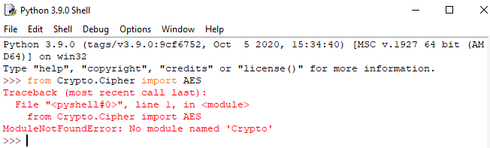

No problem, just install Pycryptodome.  
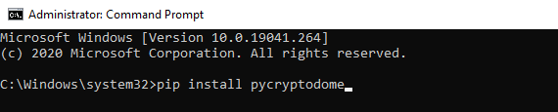

The result is a lot of nasty error messages.  
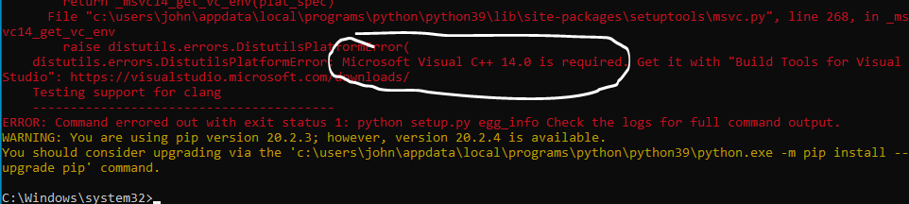

The key line is:  
Microsoft Visual C++ 14.0 is required. Get it with "Build Tools for Visual Studio": <https://visualstudio.microsoft.com/downloads/>

We need to install the "Build Tools for Visual Studio."

## Download and Install the Build Tools

This link takes you to the Build Tools.  
<https://visualstudio.microsoft.com/downloads/#build-tools-for-visual-studio-2019>

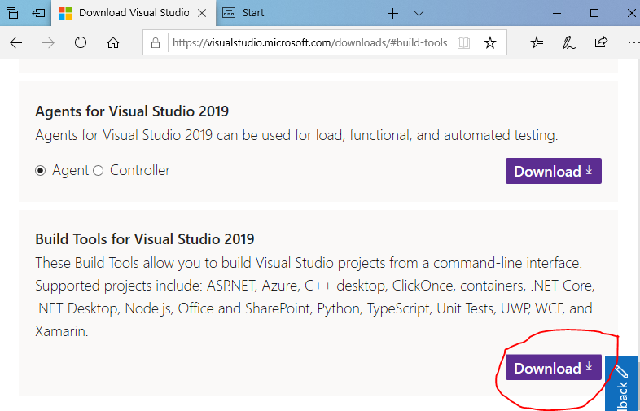

You should find a file like this in your Downloads folder.  
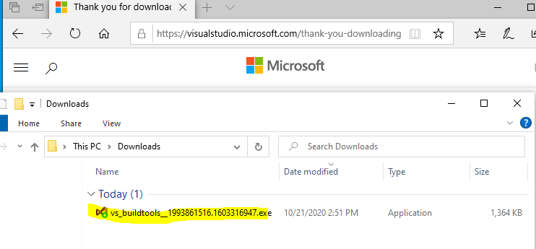

When you execute it, it begins to download and install part of the Community version of Visual Studio.  
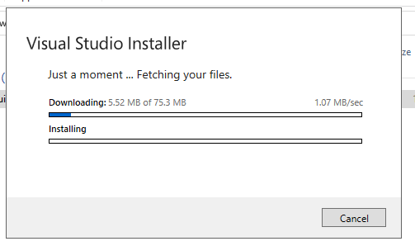

Eventually you get this window. We need the C++ build tools. I was able to deselect the C++ AddressSanitizer (Experimental) without problems. When I deselected all of the optional components, Pycryptodome would not install.

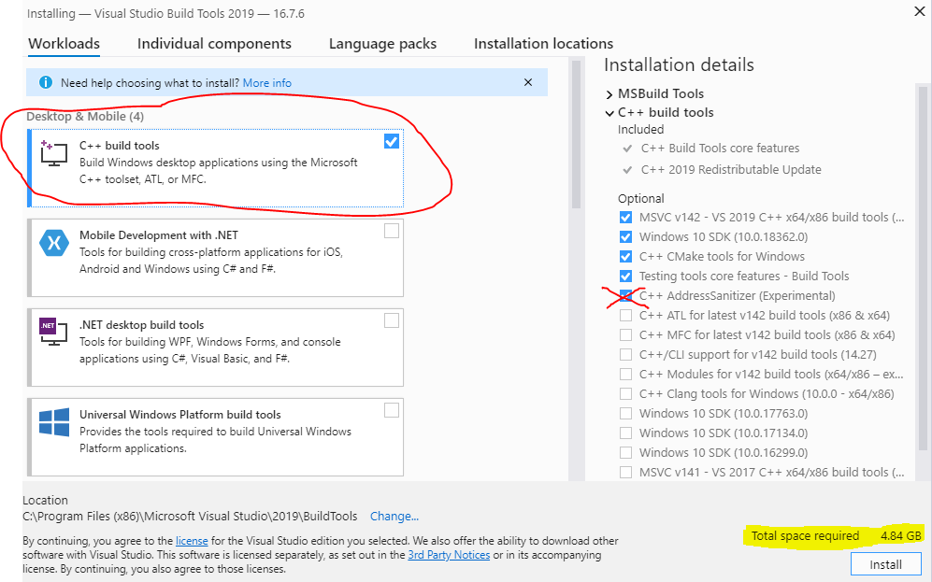

After downloading 1.2 GB and installing many packages, the installation completed.  


## Install Pycryptodome

Execute pip install pycryptodome from an elevated command prompt (run as administrator).  
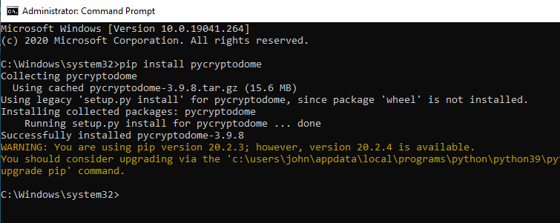

Success!

## Use Pycryptodome in Python

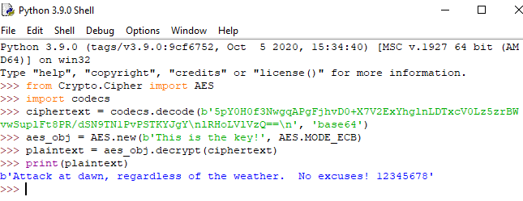

It works!